Deformation Imaging: 7th Hands-on Course in Strain Imaging
Wednesday, October 25 2023 at Ångströmlaboratoriet, Uppsala
In cooperation with GE

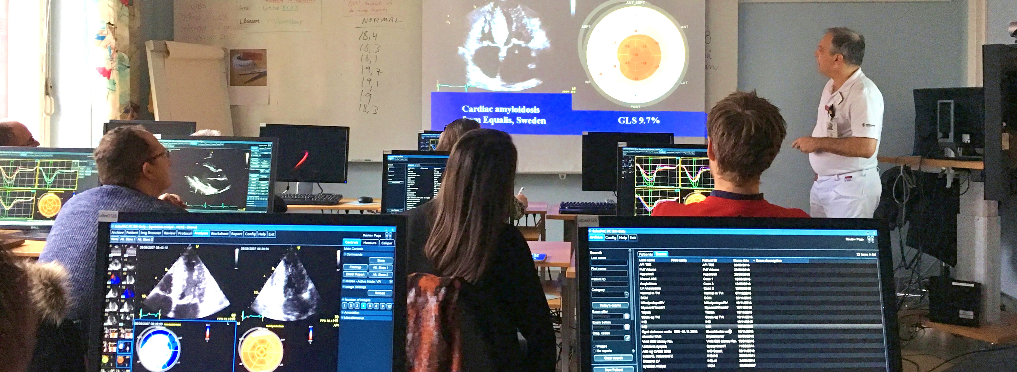
Program
09:30-09:45 | Welcome & course introduction | Frank Flachskampf, Uppsala
09:45-10:15 | Basics of deformation imaging. Tissue velocity and deformation, speckle tracking, concepts, methodologies, image quality, pitfalls Per Lindqvist, Umeå | Per Lindqvist, Umeå
10:15-10:30 | Coffee break
10:30-11:50 | Introduction followed by hands-on instruction at EchoPAC® workstation: Patient cases. Strain imaging. Event timing. AFI 3.0. | Lars Måge, GE
11:50-12:30 | Strain-mätning i vardagsarbetet | Jan Engvall, Linköping
12:30-13:20 | Lunch break
13:20-13:50 | Role of strain imaging in today’s clinical cardiology | Frank Flachskampf, Uppsala
13:50-14:15 | Illustrative clinical cases | Per Lindqvist, Umeå
14:15-14:30 | Coffee break
14:30-15:20 | Advanced perspectives: Twist, torsion, 3D strain, layer strain, synchrony, TTP (time to peak), PSD (peak strain dispersion), Myocardial Work. LA Strain. RV Strain. Hands-on instruction at EchoPAC® workstation: Using advanced tools + patient cases | Lars Måge, GE
15:20-15:30 | Open discussion & farewell
15:30- | “Researcher’s Corner”: How to export data? And other questions. | Lars Måge, GE

About the course

The course is a mix of teaching, electronic patient cases and hands-on, in Swedish and English. The Course fee is SEK 1500,- (ex. moms, incl. lunch and coffee breaks). Limited seats, first come – first served practical tasks. A computer will be provided for every participant.

Location
Ångströmlaboratoriet Uppsala, Regementsvägen 1, 752 37 Uppsala, Hus 10 - see map on the back). From Uppsala C, take bus line nr.4 in the direction of Gottsunda to the stop “Polacksbacken”.

Registration
Sign up for the course by contacting Suzanna Wildebac, BMA and administrator:
suzanna.wildebac@akademiska.se
Varmt Välkomna !
Frank Flachskampf Lars Måge,
ÖL, Professor, Uppsala University Clinical & Application Leader, GE






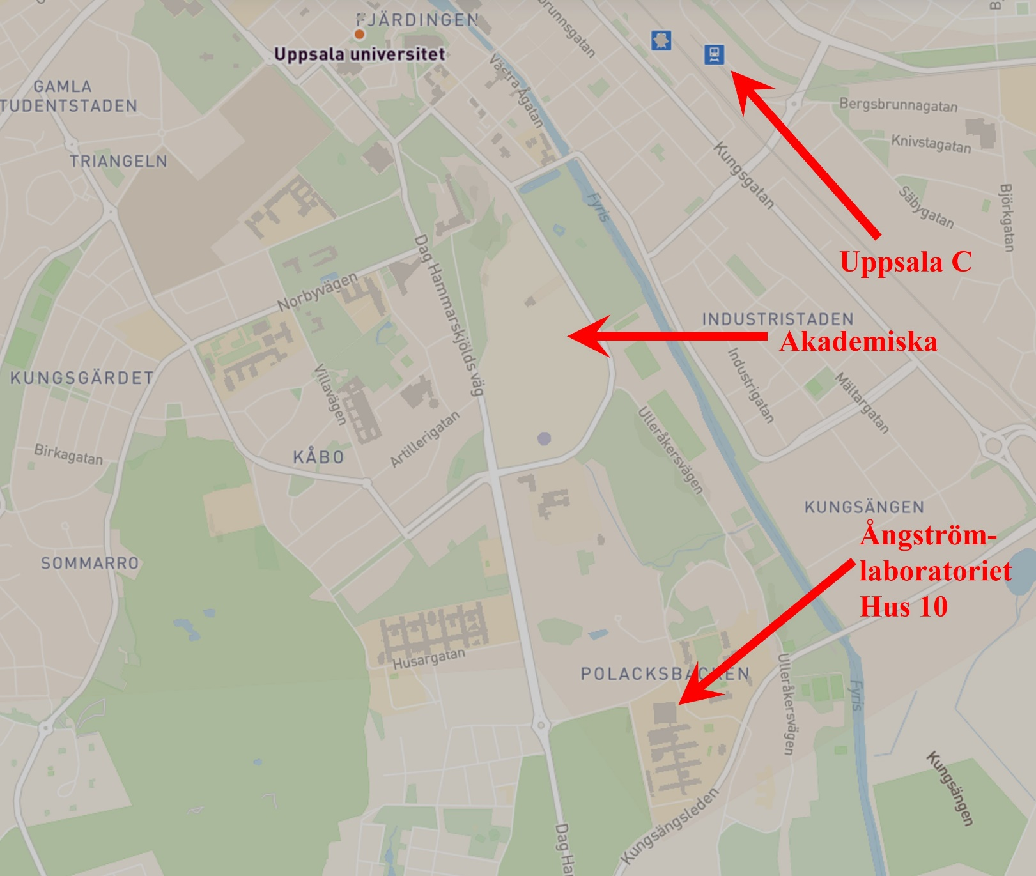
https://use.mazemap.com/#v=1&config=uu&zlevel=2&center=17.640710,59.845643&zoom=15.4&campusid=49

